Two Point
Program Description:
Create a program which graphs two points and then graphs the line formed by those two points. Program finds aspects of the line through calculation.
Rubric:
“B”
- Y Intercept - Midpoint - Equation - 2 points - Distance - Slope

“A”
- user friendliness -able to click points on graph -continuous lines -triangle form - more than 2 points
Sample output:
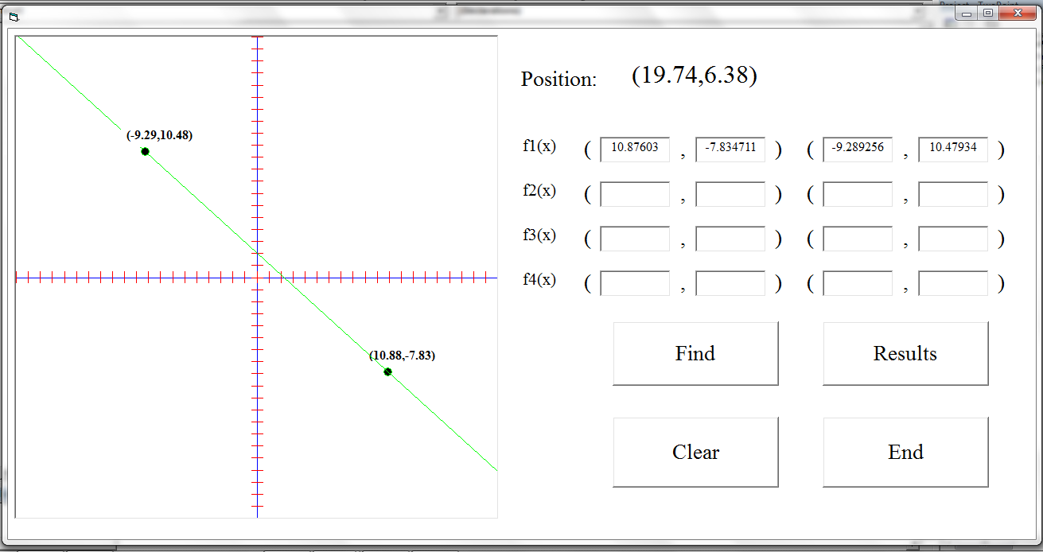
1. Gui before any input/Gui after clear button: 2. Graphing by clicking
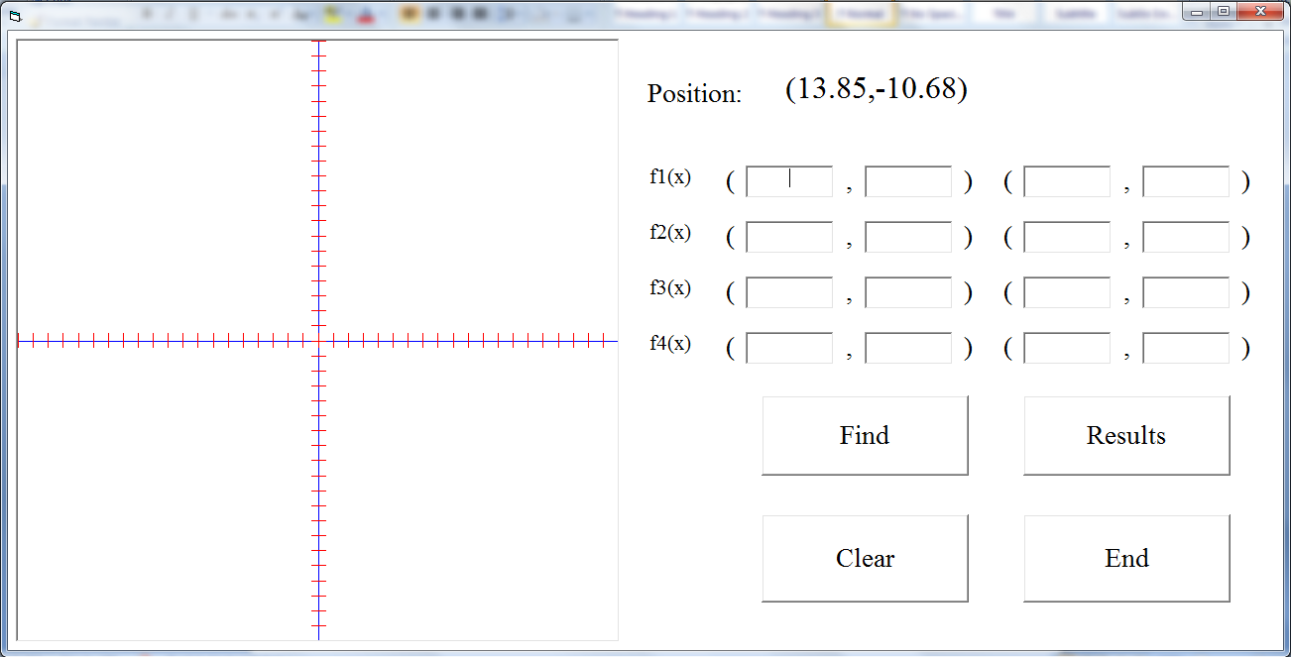
3. Graphing by inputting coordinates* 4. Graphing Two Lines
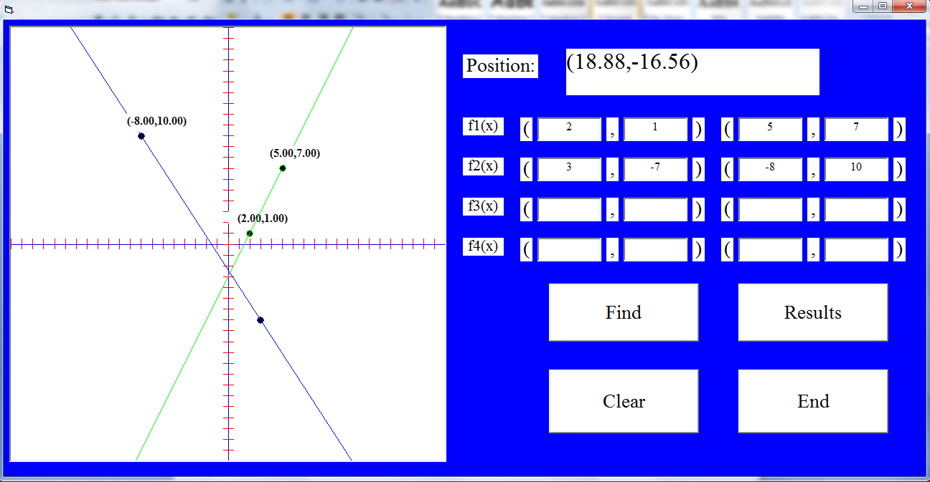
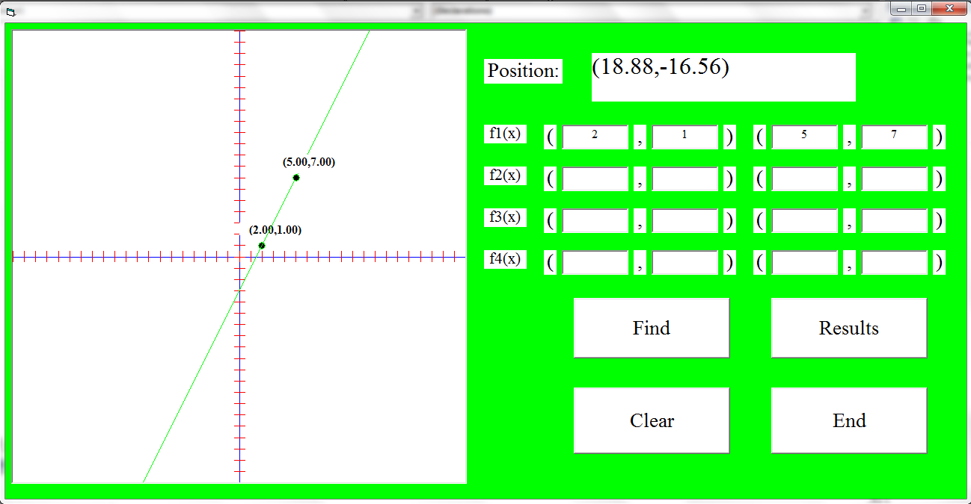
5. More than 2 points ** 6. Showing the Results ***
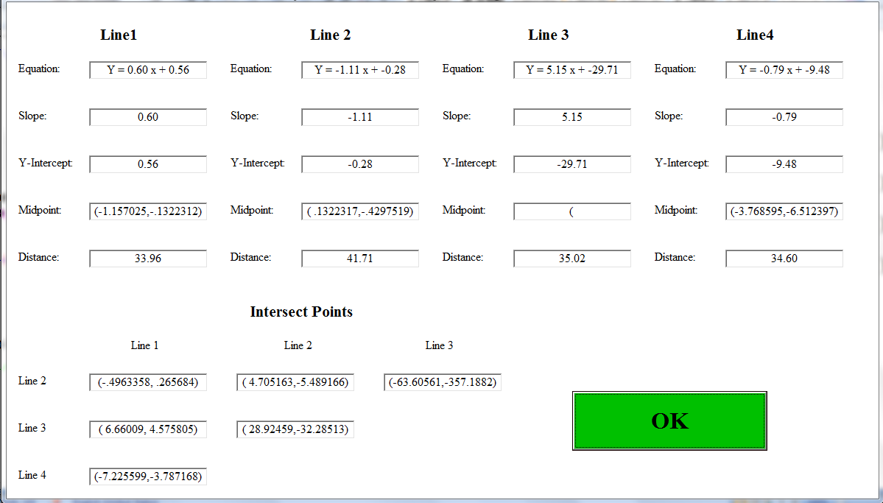
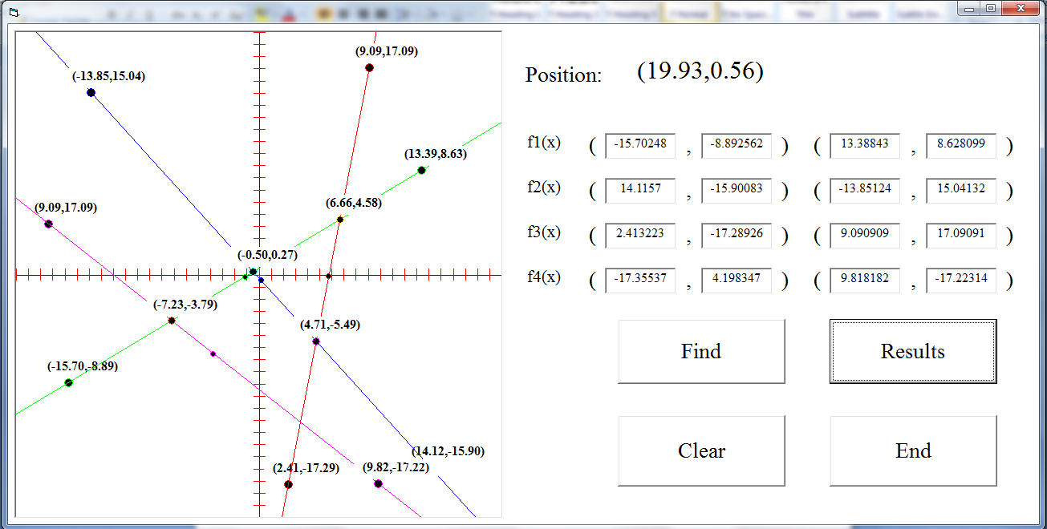
* Program changes color based on line color
**Figure 5 done through graphing by clicking, Find button finds the intersects and shows the points
***Results are shown in different form/not required

